**Self-service deployments**

The template that is included requires specific connection details for self-service deployment architectures.

To get the database connection details, you will first have to request JIT access from LCS for the environment you want to connect to

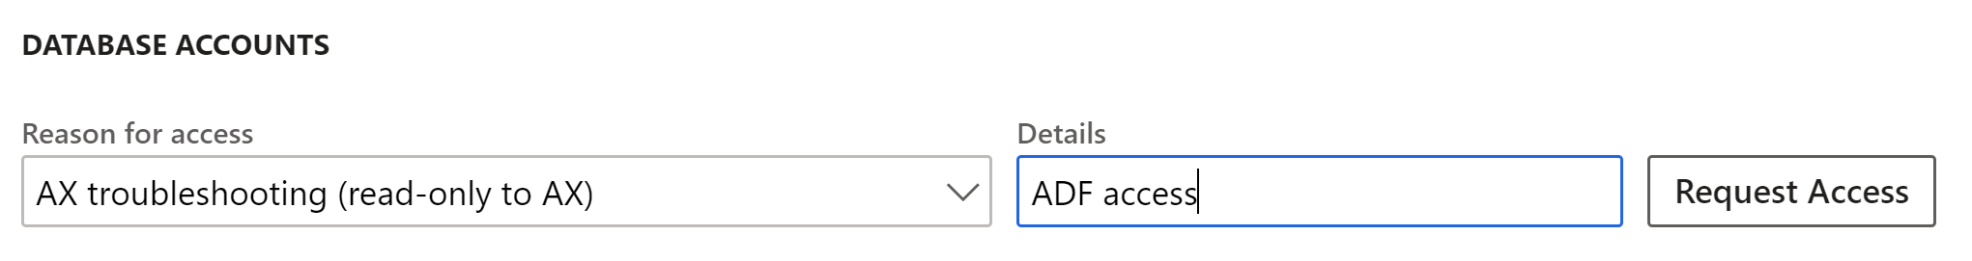

Once JIT access to received you will have access to the information required below.

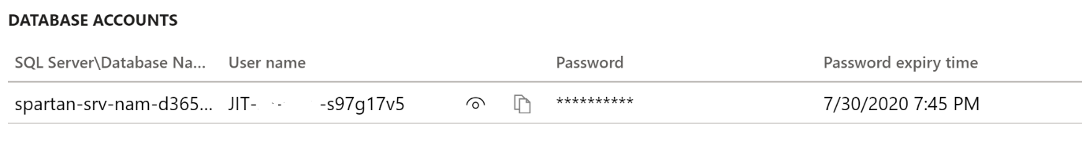

1. Populate the **New linked service (Azure SQL Database Managed Instance)** dialog with the connection details from LCS.

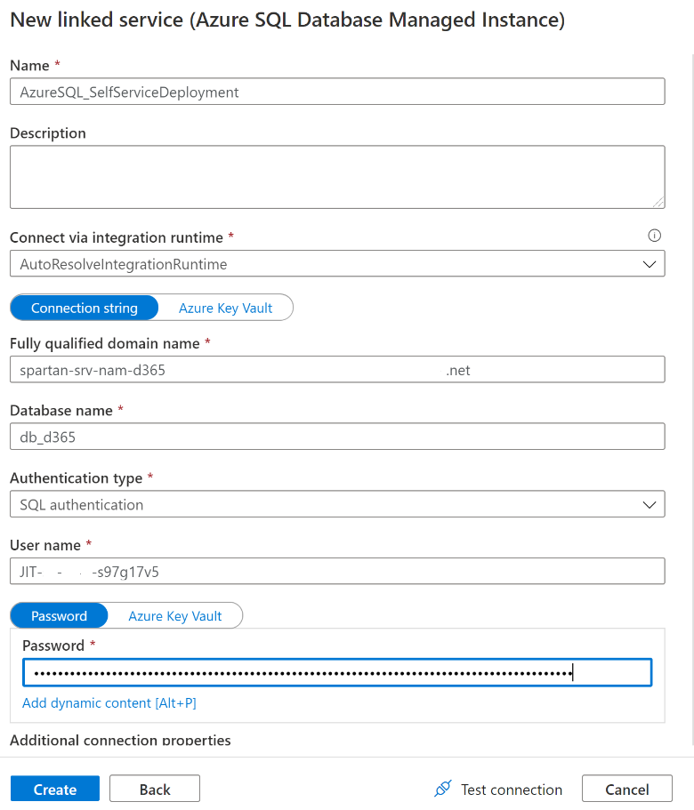

1. Click on the **Test connection** button. It is likely that the connection will fail, this is due to the firewall configuration. Click on the More link to see a message like the one below, from there make a note of the **IP address**.

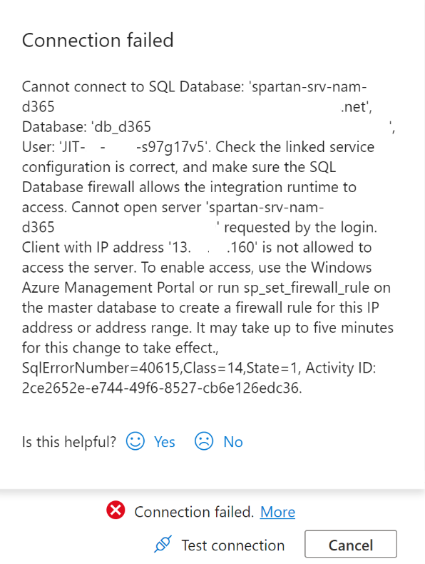

1. Within LCS and the environment page you are trying to connect to, click on Maintain > Enable access

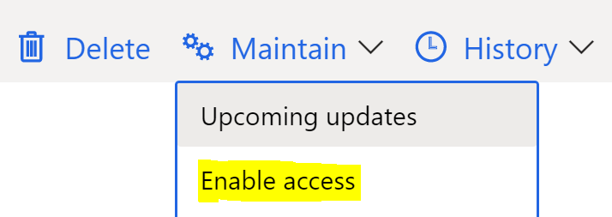

1. Using the IP address retrieved from the connection test, create a new inbound rule.

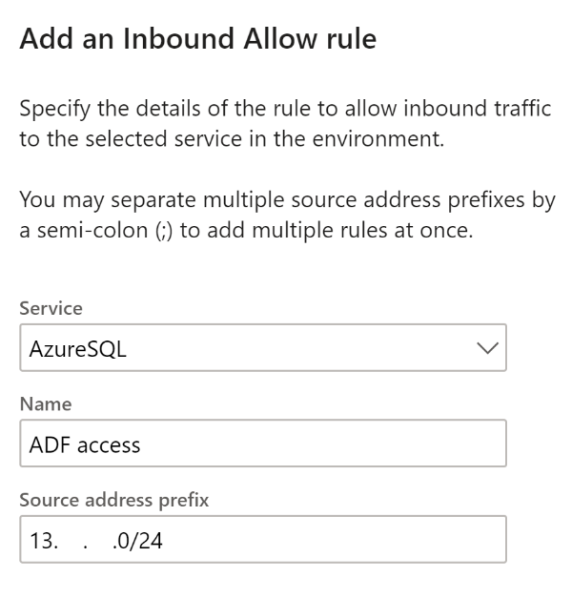

1. Once the inbound rule has been created, go back to ADF and click on the **Test connection** button again, you should see **Connection successful**. Then click on the **Create** button.

